Payment Claim Procedure

This form is used for all of the below
- Payment claims are limited to a value of £100. See below re exception.
- Purchases over £100 where no other payment method could be found and prior approval has been sought from the Financial Controller

Please note the Students’ Union (and therefore all JCR’s) are VAT registered. This means that costs from Vatable companies are subject to VAT (we can claim back VAT on costs incurred – the VAT is held/ registered centrally and claimed back from HMRC quarterly).
When completing the payment claim form you do not need to worry about adjusting the value for VAT. The finance office will do this for you.
However please note we can only claim VAT back from VAT registered companies where their VAT number is included on their receipts, so if the receipts you attach to the form does not include this we will not be able to adjust the value for Vat in your accounts.

To complete the form.

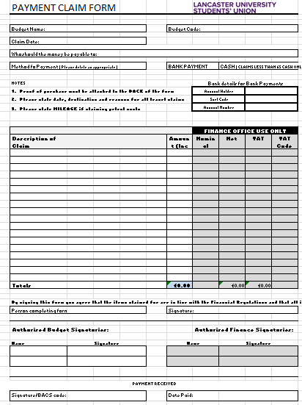

Once you know what you wish to purchase and before the purchase takes place.
- Get an idea of how much you think the items you are purchasing will cost you before VAT. Then check with your treasurer/equivalent that enough money is left in the budget to purchase these items.
- If in any doubt ensure you are eligible for expenses with the Financial controller or VP Union Development before making the purchase.
- Payment claims shall be submitted at the earliest opportunity, and no later than two months after incurring the expenditure. The amounts claimed shall be supported by receipts where these might reasonably be expected to be obtainable. These should be full VAT receipts and not credit card flimsies or copies of bank / credit card statements. The receipts should be collected within 2 months and if not the claim amount will be reimbursed back into the relevant budget code.

A link to an e version of the form to fill out and print and sign can be found at https://lancastersu.co.uk/resources/payment-claim-form
With this form the budget name and budget code are the account to be debited.
For JCR’s this is your JCR name and the area of your budget you wish to take the money from. E.g. Pendle Sports. The code is the codes you were provided with at the start of your term in office. An example of budget codes using Pendle is below
BUDGET CODES
 | Income
JP01 | JCR Capitation
JP02 | JCR Machine Monies
JP04 | JCR Other Income
 | Expenditure
JP15 | JCR Administration
JP20 | JCR Other Expenses
JP22 | JCR Media and Communications
JP30 | JCR Other social functions ( inc ppl)
JP33 | JCR Christmas Dinner
JP35 | JCR Summer Extravaganza
JP40 | JCR Welfare and Campaigns
JP55 | JCR Founders/Legends/Patriots
JP60 | JCR Sports Equipment & Expenses
JP61 | JCR Intro Week
JP63 | JCR TV/AV Equipment and Costs

If you wish to claim for more than one item on the same claim form; please write the area / JCR name and the word ‘various’ as the budget name. Then next to each item listed in the claim description mark the budget name and code they are to be paid from.
The claim date is today’s date.
Who should the money be payable to is the person who originally spent the monies. This may be different to the person completing the form.
Method of Payment. Please indicate if the claim is to be paid in cash or into a bank account. (Bank Payments will not be paid for less than £5 due to charges involved). If the claim is for cash the person should come to collect the cash with ID.
Bank details for Bank Payments. If a payment is to be made into a persons’ bank account please provide the relevant account details. This must be completed for ALL claims even if details have been provided on a previous claim.
Description of claim. Please fill in a brief description of what the money is for grouped by type of item. You do not need to list every individual item on the receipt. E.g. decorations for Welcome Week. (If claiming from more than one budget code; write the budget code in this section next to the relevant items).
If you wish to claim petrol expenses, you must put in a claim for mileage. In this case, in the description section provide details of date of travel, start point and destination and reason for travel. Also list the number of miles travelled. This is this multiplied by the 45p per mile e.g. a journey of 10 miles each way. Claim would be for 20*£0.45 = £9
Next list the Amount (cost) of each item on the claim in the relevant column. This is the full cost including any VAT. The finance office will deduct any VAT possible before coding the cost to your accounts.
The Total should fill in automatically at the bottom of this column.
 | Description of Claim |  |  |  |  | Amount (Inc VAT)
 | Totals |  |  |  |  | £0.00

Person completing the form. This section is important as by filling out the form and signing this declaration you are agreeing to the below statement
By signing this form you agree that the items claimed for are in line with the Financial Regulations and that all information is accurate

The name of the person who actually filled in the form must be provided and they must sign the form. This may not be the same person who the money is payable to.
Now the budget signatory/signatories need to sign the form (other than the person the money is payable to). For JCR’s two JCR authorised finance signatories (other than the person the money is payable to) need to sign the form. One must be the Finance Officer unless a claim is for them. You cannot sign your own claim.
Finally attach any receipts to the back of the form as proof of monies spent.
The form can now be brought to the Finance Office and the cash can be collected twenty four hours later at the earliest. BACS will be paid directly into the relevant bank account on a weekly basis.

